KARNATAK LAW SOCIETY’S

GOGTE INSTITUTE OF TECHNOLOGY

UDYAMBAG, BELAGAVI-590008

(An Autonomous Institution under Visvesvaraya Technological University, Belagavi)

**(APPROVED BY AICTE, NEW DELHI)**



*Course Activity Report*

**SOFTWARE PROTOTYPE**

*Submitted in the partial fulfillment for the academic requirement**of*

***4th Semester B.E.***

***in***

*Software Engineering*

*Submitted by*

**NAME OF THE CANDIDATE USN**

Abhishek M 2GI18CS004

Arvind Tadasad 2GI18CS030

Aditya Bhadragond 2GI18CS034

Chetan Gavimath 2GI18CS037

**GUIDE**

Prof. Vijay Rajpurohit

**2019– 2020**

**Marks allocation:**

|  |  |  |  |  |  |  |
| --- | --- | --- | --- | --- | --- | --- |
|  | Batch No. : | | | | | |
| 1. | Project Title: People come to cities because of better health facilities. What should be done to improve the health facilities in the city and provide equitable access for all? | Marks Range | USN | | | |
| 2GI18CS004 | 2GI18CS030 | 2GI18CS034 | 2GI18CS037 |
| 2. | Problem statement (PO2) | 0-1 |  |  |  |  |
| 3. | Objectives of Defined Problem statement (PO1, PO2) | 0-2 |  |  |  |  |
| 4. | Design / Algorithm/Flowchart/Methodology (PO3) | 0-3 |  |  |  |  |
| 5. | Implementation details/Function/Procedures/Classes and Objects (Language/Tools) (PO1,PO3,PO4,PO5) | 0-4 |  |  |  |  |
| 6. | Working model of the final solution (PO3,PO12) | 0-5 |  |  |  |  |
| 7. | Report and Oral presentation skill (PO9,PO10) | 0-5 |  |  |  |  |
|  | Total | 20 |  |  |  |  |

**\* 20 marks is converted to 10 marks for CGPA calculation**

**Signature of Staff In Charge.**

**SOFTWARE ENGINEERING COURSE ACTIVITY REPORT**

**STORY CARD: -**

**Health Facilities and Government schemas in urban city**

When people from rural area come into urban city in search of health facilities, they don’t know which hospital is less or which will cost them less bill.

For making this easy the user needs to input the city name in the system and the system will display a list of government hospitals which are best in the city and also the system will provide the user the address and contact details and working hours(timing) of the hospital which will help the user to reach the health facility and can also contact the health facilities for queries.

Also, the system will provide the user with list of government schemas available in the health facility which will reduce the cost of treatment of the user.

**TASK CARDS: -**

**Task 5: Display the list of Government Schemas available in the facility.**

After choosing the health facility the system must also provide the user with the list of all the government schemas available in the health facility.

The government schemas will reduce the cost of treatment of the user.

**Task 4: Display the address, contact details, etc. of the health facility chosen.**

**Task 3: Choose a health facility.**

**Task 2: Display the list of all best health facilities in the city.**

**Task 1: Take location of the user as input.**

**TEST CARD: -**

Test case description for government schemas available in the health facility.

**Test: -** Government Schemas Availability

**Input: -**

Name of the health Facility.

**Tests: -**

Check whether government schemas are available in the health facility selected.

**Output: -**

If Government schemas are present then display the list of all the government schemas available in the health facility.

**PROTOTYPE TOOL DETAILS: -**

The software used for development of the prototype is **Adobe XD.** Adobe XD is a vector-based user experience design tool for web apps and mobile apps, developed and published by Adobe Inc. It is available for macOS and windows, although there are versions for iOS and Android to help preview the result of work directly on mobile devices.

Adobe first announced they were developing a new interface design and prototyping tool under the name "Project Comet" at the [Adobe MAX](https://en.wikipedia.org/wiki/Adobe_MAX) conference in October 2015. This was in response to the rising popularity of [Sketch](https://en.wikipedia.org/wiki/Sketch_(software)), a design platform released in 2010 which replaced [Adobe Photoshop](https://en.wikipedia.org/wiki/Adobe_Photoshop) as the industry leading design platform for UI and UX design.

The first public beta was released for [macOS](https://en.wikipedia.org/wiki/MacOS) as "Adobe Experience Design CC" to anyone with an Adobe account on March 14, 2016. A beta of Adobe XD was released for [Windows 10](https://en.wikipedia.org/wiki/Windows_10) on December 13, 2016. On October 18, 2017, Adobe announced that Adobe XD was out of beta.

**SCREENSHOTS OF EACH SCREEN IN PROTOTYPE: -**

Home Screen: -

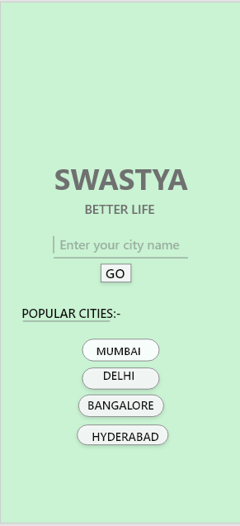

Screen 1: -

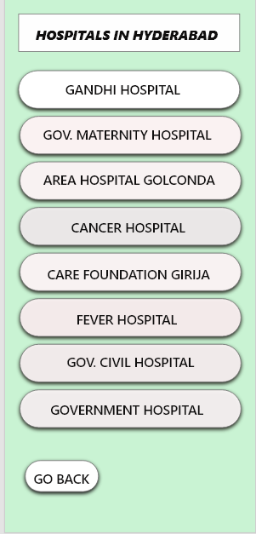

Screen 2: -

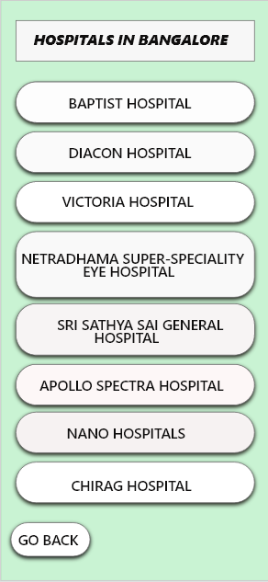

Screen 3: -

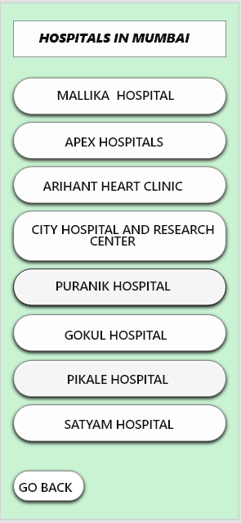

Screen 4: -

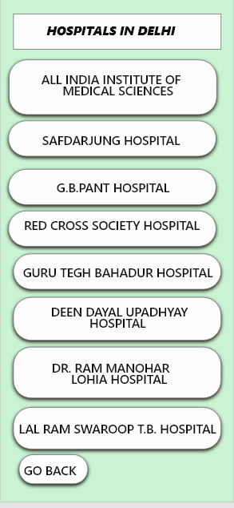

Screen 5: -

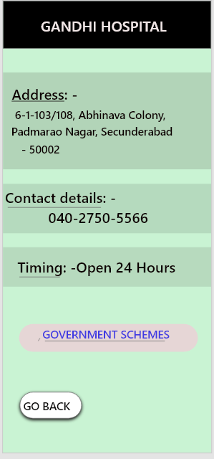

Screen 6: -

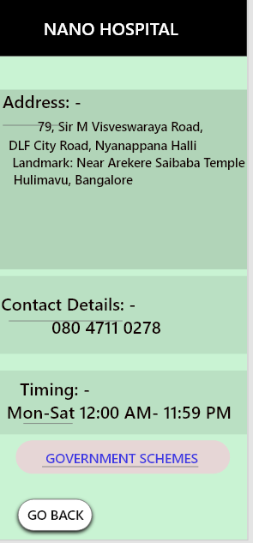

Screen 7: -

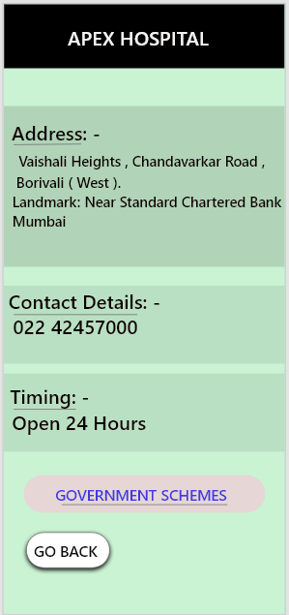

Screen 8: -

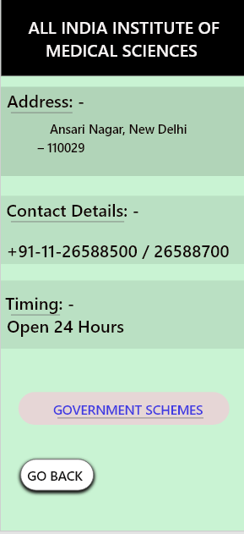

Screen 9: -

